Andy Ni

COMP 3710

Testing Document

1. Open App

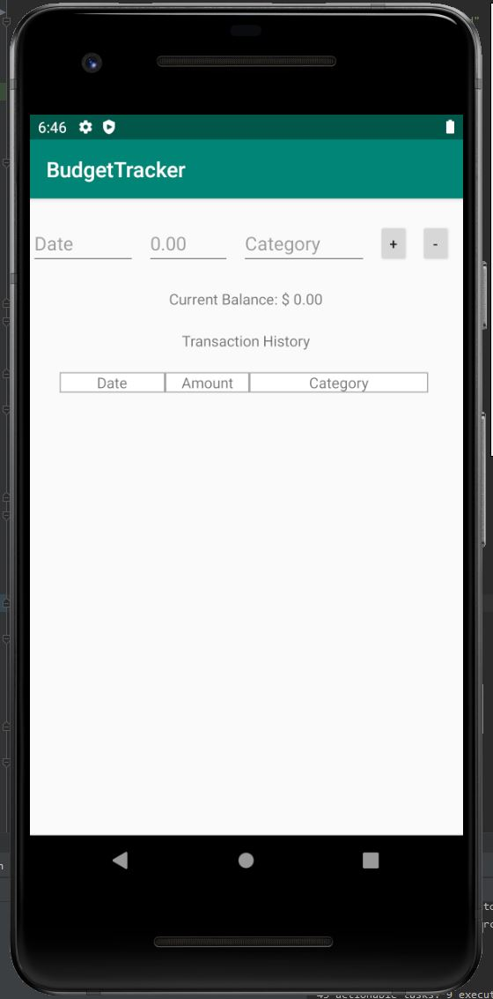

1. Pick a Date, Enter Cost and Category and click Add Button

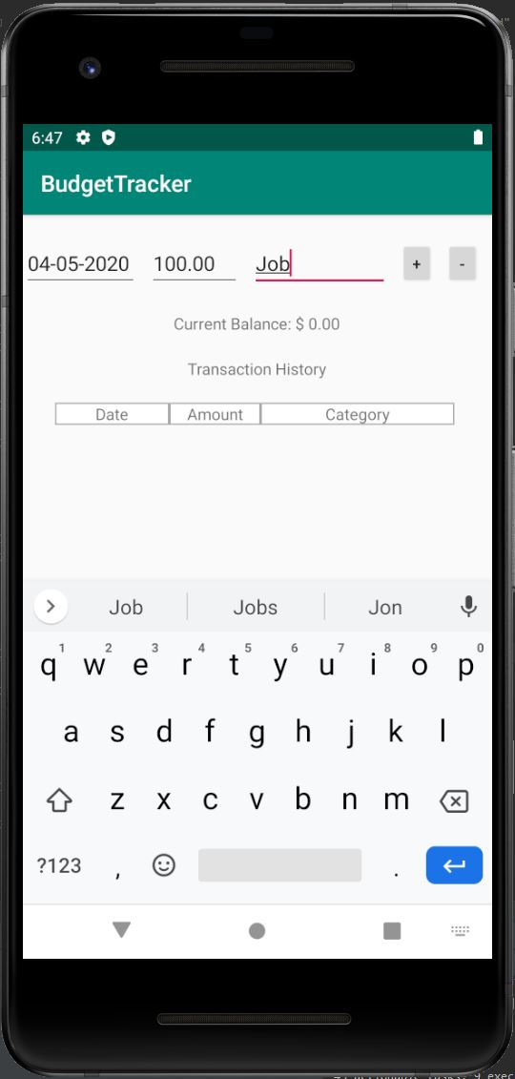

1. App history and balance is updated

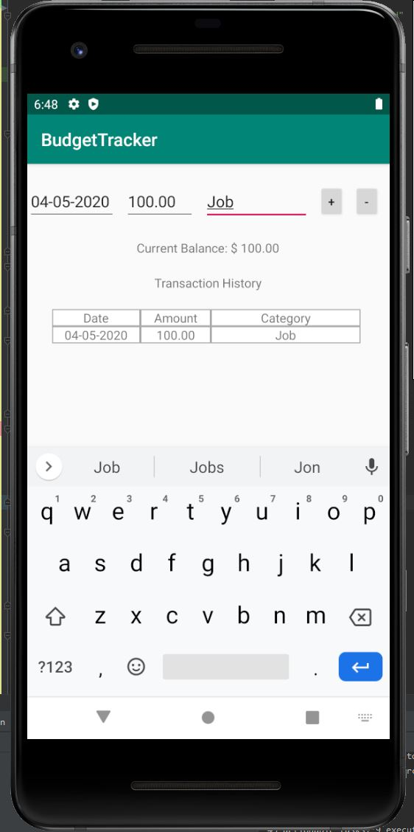

1. User uses expense function. Balance and history is updated again.

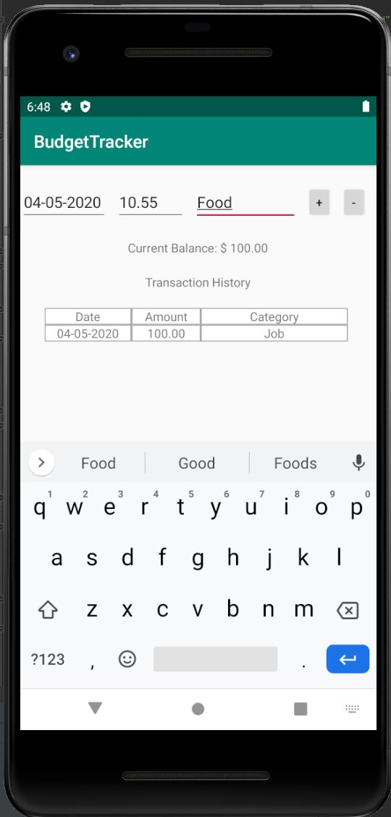

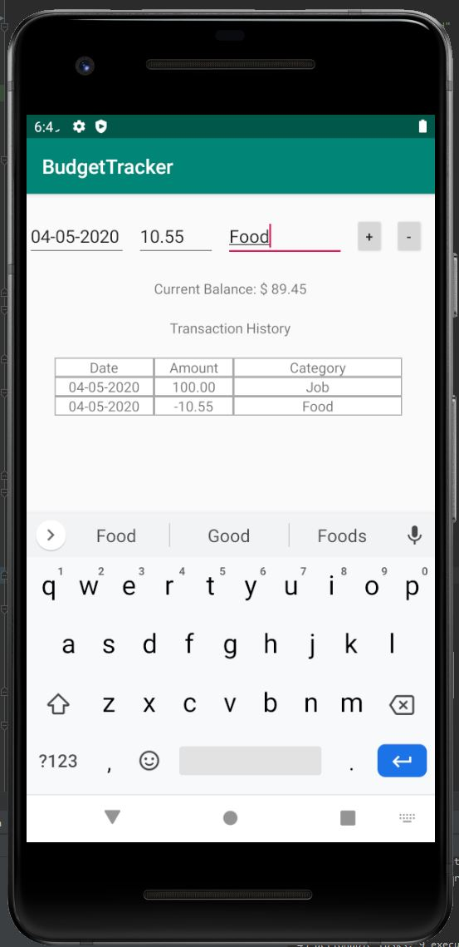

1. Closing and Reopening App, App has old information saved

